The People’s Assembly, convening on the 18th of August 2020 under the 20th PA Meeting.

The Assembly, recognising the current situation,

Constituting that New Argos wants to become an island; requests a border expansion as seen in the picture.
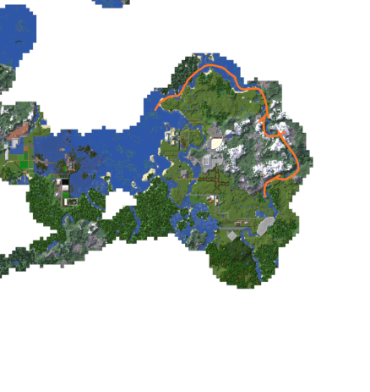

And proceeds.

Signed by,
eldegron
Tsarsteven

[Motion as: 20-16: “Expand new Argos borders in order to turn it into an island”]

